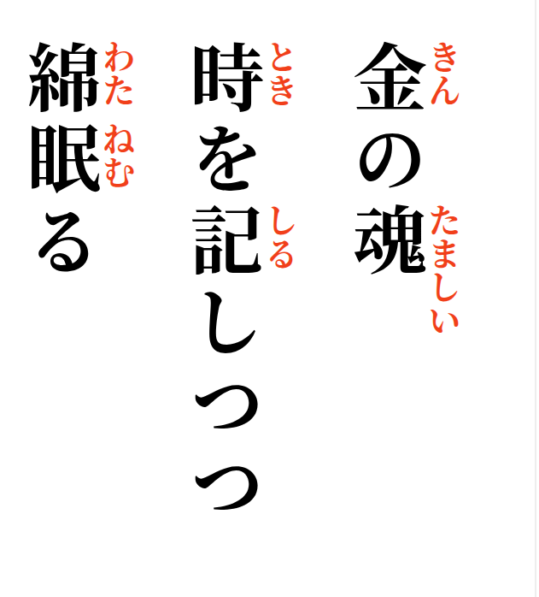
Golden spirit,
quietly noting down time—
the cotton sleeps.

